## **Project “Kongōjō” 1.5-Page GDD**

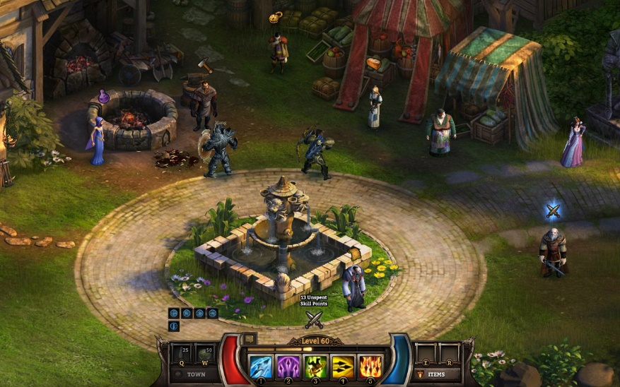*From the book of B.Akunin “Diamond chariot”*

**Genre:** RPG  
**Target Audience:** 13+. Fans of RPG like Diablo, but also detective games.

**Controls:** Mouse/Keyboard

**Thematic Setting:** Japan 1878

**Tech Stack:** Unity 2020.3.32f1, Asset Strore,

**Platform(s):** Steam

**MVP Game Moment:** 5 minutes of story telling/linear level flow with combat against 3 or 4 enemy types.

**Game Summary:** Project “Kongōjō” is about a Gaijin Erast, who came to Japan as a vice-ambasador of his Emperror. He is a man of honor, extremely talented for his age and very curious, with detective’s mindset. He finds the love of his life and discovers old Ninja’s clan and their lifestyle. He starts by investigating a strange death of a man and discovering Japan of that time and the city’s Protogonists and Antogonists.

**Core Player Experience:** Joy ofCompleting aMission and Curiosity for Further

**Central Story Theme:** Detective/Ninja

**Design Pillar:** Putting a player in difficult choice situation, create an eager for the story continuation.

**Remarkability:** “Magic” surrounding the player is possible, but not reachable.

**Anticipated Steam Early Access Launch date:** end of 2022.

**Feature Development Priorities:**

* Story-telling system and choice system
* Real-time combats with tons of different enemies.
* All the required RPG abilities and stats (upgradeable)
* Level building and Game Progression
* Branching Dialogue System
* Inventory, Loot, Usable Items

**Reference Games:** Ember, Torchlight 2, Diablo, BattleHeart: Legacy